JUNE 16, 2019
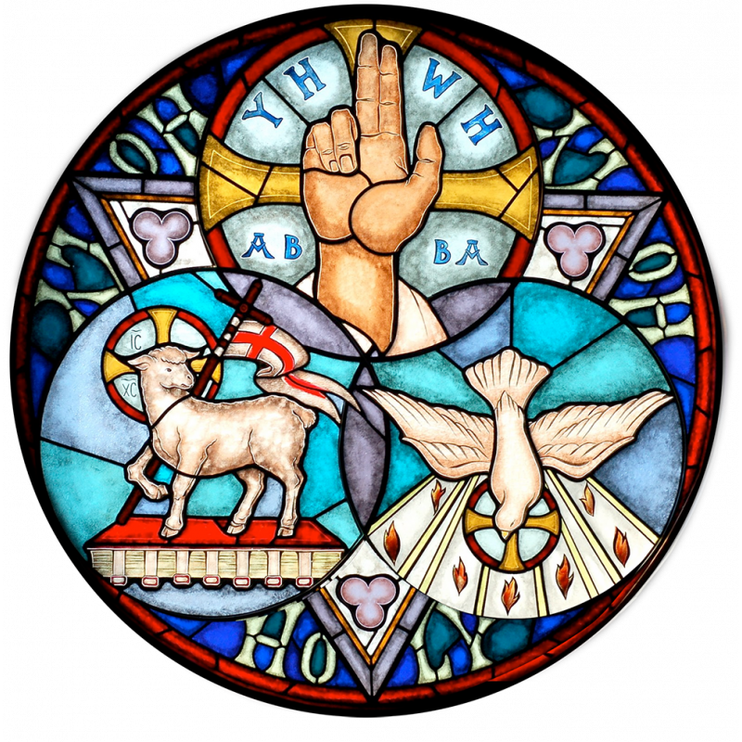
10:45 AM WORSHIP

SIERRA EVANGELICAL LUTHERAN CHURCH
101 North Lenzner Ave., Sierra Vista, AZ 85635
(520) 459-0444 - www.selcaz.org

Our Mission Statement:
“With faith in God’s grace, we share Christ’s love with all,
so that lives are transformed by the Holy Spirit.”
Mark Perry, Pastor
Amy Janssen, Intern Pastor
Linda Perry, Director of Faith Formation
Larry Rewis, SELC Council President
Cindy Allen, Administrative Assistant
Ministers: The People of SELC

You Are Invited again to Sunday Worship Services
Next Week at 8:00 a.m. & 10:45 a.m.

Nursery for children Birth – 4 yrs is available at both worship services. Parents are also welcome to use the Comfort Room as a private area to take your infant or young children if you would like. Located just off the Lobby.

WELCOME TO SELC - Please sign your name in the red fellowship pad from the pew rack in front of you. All are welcome at the communion table, regardless of denominational background or life circumstance. To learn more about what it means to be a devoted Christ-follower, and how Baptism is an essential entrance rite into that life of discipleship and service, please talk to the pastor or intern pastor. White grape juice is available as well as gluten-free wafers. Please indicate your preferences to the server.

PRAYER REQUESTS for the month of JUNE can be submitted online at www.selcaz.org or to Leslie McCourt at mccourtleslie@gmail.com.

Please pray for Tony Toto, Jan and Don Huthoefer. Please continue to pray for Peggy Graham, Bob Reiner, Carlie, and Mikki Shaner. the family of Bill Hall, Caroline Pentecost, Tony Lawhead, Grady Taylor, Phil, Bob Reiner, Sue Mount, Matt Hunter, Rob, Elaine Pinnt, George Abraham, Jane Behsman, Dolly Bessler, Jan Bevelin, Dee Brenner, Clayton, Kriss Larsen, Helen Lecomte, Mahkyla, the family of Michaela MacVilla, Carol Moses, the Nowaks, Shawn Nowrey, Pete and Dee Pederson, Jerry Regan, Roger and Dee Rowley, Virginia Studer, Pam Williams and military personnel everywhere.

TODAY we celebrate and give thanks for fathers and father figures in out
lives! All men are invited to receive a special gift from the children and youth
of SELC on the patio today after each service.
HOLY TRINITY
(* = Please stand as you are able)

GATHERING

Pre-Service Song
“We Believe” (Travis Ryan, Richie Fike and Matt Hooper)

Welcome

*Confession and Forgiveness

*Gathering Hymn “Holy, Holy, Holy, Lord God Almighty!” ELW #413

*Prayer of the Day

WORD

First Reading: Proverbs 8:1-4, 22-31 Pew Bible pg. 515

Psalm 8 (Chanted, led by Cantor Cindy Wiste)
Tone 7

Second Reading: Romans 5:1-5 Pew Bible pg. 917

*Gospel Acclamation ELW #510, vs. 3 only
“Word of God, Come Down to Earth”

*Gospel: John 16:12-15 Pew Bible pg. 879

Children’s Time

Choir Anthem “Majesty” (J. Hayford)

Sermon Pastor Mark Perry

Moment of Silent Reflection

Hymn of the Day “Come, Join the Dance of Trinity” ELW #412

*Nicene Creed ELW pg. 104

*Prayers of the People (to the conclusion, “Lore, in your mercy,”
please respond, “hear our prayers.”)

*Sharing of the Peace

MEAL

Offering

Offering Music "I Wanna Thank You, Lord" (P.F. Simms)
Presented by SELC Choir

*Offering Prayer

*Holy Communion

*Words of Institution

*Lord’s Prayer (sung)

Invitation to Communion

Songs during Communion
“Praise The Father, Praise the Son” (Chris Tomlin, Ed Cash)
“Father, I Adore You” TOSB #40; repeat as the Spirit leads

*Prayer after Communion

SENDING

Announcements

Blessing

*Sending Hymn “This Is My Father's World” ELW #824

*Dismissal

Postlude “Voluntary on Sending Song” (arr. B. Hayes)

Scripture Readings for Next Sunday
Isaiah 65:1-9
Psalm 22:19-28
Galatians 3:23-29
Luke 8:26-39

Faith 5 Verse for this week is John 16:13:
“When the Spirit of truth comes, he will guide you into all the truth.”

Copyright © 2016 Augsburg Fortress. All rights reserved. Reprinted by permission under Augsburg Fortress Liturgies Annual License #SAS023047. New Revised Standard Version Bible, copyright © 1989, Division of Christian Education of the National Council of the Churches of Christ in the United States of America. Used by permission. All rights reserved

Flowers Provided by
Dave and Beth Dechant in celebration of their 50th wedding anniversary.

Oil for The Eternal Light to the Glory of God.

SERVING TODAY

Altar Guild
Becky Randall, Lisa Mitchell,
Rhea Scott

Acolyte
8:00 a.m. – Becky Randall
10:45 a.m. – Mariana Martinez

Crucifer
8:00 a.m. – Carl McCourt
10:45 a.m. – Carl McCourt

Deacons/Communion Assistants
8:00 a.m. – Deacons Jane Strain
10:45 a.m. – Deacon Carl McCourt

Greeters
8:00 a.m. – Myrna Meyer, Frankie Appelin
10:45 a.m.– Maggie Vaughn, Bill Clemens

Lector
8:00 a.m. – Carl McCourt
10:45 a.m. – Gary Graham

Interim Music and Choir Director
Sunny Fichtl

Organist & Pianist
Billie Hayes, Deb Koltveit

Partners in Praise - Betty Burford, Victoria Kiser, Linda Perry,
Amy Janssen, Cindy Wiste

AV Technicians - Bill Silvis, Larry Rewis, CJ Abraham, Fred March,
Dave Dechant

Ushers for Today
8:00 a.m. – *Jim and Virginia Cleven, Glen Sanner
10:45 a.m. – *Anna Bratlien, Gary Peterson, Richard Zimmer

FAITH FORMATION FOR ALL AGES WILL NOT BE HELD JUNE 16 – JULY 28.
CLASSES RESUME AUGUST 4.

INQUIRERS’ CLASS – SUNDAY’S 9:30 am in the Fellowship Hall. Anyone interested in learning some of the basics about what it means to be a Lutheran Christian and how we live out our Christian mission here at SELC, including through becoming a voting member, is invited to the “Inquirers’ Classes.” Please contact Pastor Perry at 459-0444 or pastor@selcaz.org, for more information. (Please note: One doesn’t have to commit to be a member in order to attend these sessions).

YOUTH TO SERVE GOOD NEIGHBOR ALLIANCE DINNER! – June 18 – 4:00 p.m. – All Jr. & Sr. High Youth are invited to help Pastor Mark and Linda prepare, serve and enjoy dinner with GNA. We will carpool from the church or you can meet us there. We will be serving chili, watermelon, cookies and a lot of smiles! Come be a part of this special service event and help share the love and joy of Jesus with these folks! We’ll enjoy ice cream together afterwards!

BILL HALL MEMORIAL SERVICE - All are invited to join us for a Celebration of Life for Bill Hall, on Saturday, June 22 at 11:00 am, at SELC. A light lunch reception will follow in the Fellowship Hall. If you plan to attend the reception, please bring a dish to share if possible.

BUNKO PARTY FOR ALL – Saturday, June 22 at 6:30 p.m. in the Fellowship Hall. Join us for this cross generational time of fun together. You don’t need to have played before. All you need to be able to do is throw 3 dice at the same time. Feel free to bring a snack to share with others and be prepared to laugh and have a great time. Call Helen Perdiue at 520-249-8191 for more information.

CrossGenerational Vacation Bible School
Tues – Thurs evenings, June 25 – 27, 2019, 6 – 8 pm
With a light supper from 5:30 to 6 pm. At Sierra Lutheran Church
We encourage the entire household to attend VBS together…it’s for everyone! This VBS will be a great way to empower different generations and/or families to talk about and walk their faith at home to here at SELC. Children under the age of 6 must be accompanied by an adult. We begin our evening with a light supper from 5:30 to 6:00 pm in the Fellowship Hall. After we eat, we will gather
for our evening theme and learning fun around God’s Good Earth. We have a
sign-up sheet for help on the patio this morning.
Items Still Needed for All Generations VBS

- Elmer’s type glue bottles
- Magnet strip tape
- 9 oz Red Solo cups
- Sponges (plain)
- A beekeeper to speak to the groups on June 27
- Small Goat on June 25? This is the closing activity so could be brought at 7:45

VBS TEAM LUNCHEON MEETING – June 23 – 12:00 Noon in the Fellowship Hall All those who are a part of the VBS Crew are asked to attend this final meeting of preparation and review. A light subway sandwich lunch will be served. RSVP to attend when you sign up on the church patio or call the church office, 520-459-0444.

FAITH ROCKS & PIZZA! – July 1 – 10:00 a.m. to 12:30 p.m. – All children and youth – 1st Grade to 12th Grade are invited to join Linda Perry and our host, Anne Nowak, on a field trip to Cochise Rock & Stone followed by a pizza lunch at Peter Piper Pizza. We will select a special “faith” rock to set aside, that we can paint at the start of Faith Formation in the fall. We will also paint and decorate faith rocks for our homebound members at that time as well! Thank you, Anne, for initiating and hosting this very special event for our children and youth!

COFFEE SET UP VOLUNTEER NEEDED – We are looking for a hospitality minded volunteer to set up the coffee and tea cart during the 4 weekends in July. (for the Sunday services being held on July 7, 14, 21, and 28.) Set up takes about 15 minutes and can be done on Friday or Saturday. Please contact Victoria Kiser if you feel led to serve in this way. 520-678-1996

YOU CAN HELP! Did you know that U.S. Customs and Border Patrol processed more than 107,000 migrants last year alone? In fact, federal immigration authorities have released more than 5,000 people in the Phoenix area in the past two months - the vast majority of these being families. These families are part of a growing wave of refugees arriving at Arizona's borders seeking asylum. From fleeing streets filled with gangs and crime to traveling hundreds of miles in search for a better life, these families were forced to leave behind everything they've ever known - and now they need our help. Through the Lutheran Immigration and Refugee Services (LIRS), LSS-SW has been asked to help these families by partnering with churches throughout the state in order to provide shelter during transition. Our congregation is needed to provide new socks and underwear (children and adults). Won't you join us in this "Sock and Underwear Drive" during the month of June 2019. For any information about this worthy cause, ask Gail and Doug Hamp and or Linda and Rich Radwick. Thank You in advance!
TAKING FAITH HOME
JUNE 16, 2019 - TRINITY SUNDAY
Experiencing the peace of God.

DAILY BIBLE READINGS
These passages are related to the Lectionary texts for this Sunday.
Sunday | John 16:12-15 | The Spirit will guide you
Monday | Proverbs 8:1-4, 22-31 | The gifts of wisdom
Tuesday | Romans 5:1-5 | Experiencing God’s peace
Wednesday | Isaiah 55:10-13 | God’s people celebrate
Thursday | Ephesians 4:1-6 | Unity in the body of Christ
Friday | Philippians 4:4-9 | Paul encourages believers
Saturday | Psalm 8 | The wonderful name of the Lord
Sunday | Luke 8:26-39 | Jesus casts out demons

SCRIPTURE VERSE FOR THIS WEEK
Therefore, since we are justified by faith, we have peace with God through our Lord Jesus Christ. Romans 5:1 (NRSV)

PRAYERS AND BLESSING
A Prayer for the Week: Dear Triune God, you who are filled with mystery and wonder, fill us with peace, the strength to endure, a loving character, and hope that does not fail us. Amen.
Mealtime Prayer: We are thankful for food and pray for sharing God’s peace. May we speak words of praise to God and never, ever cease. Amen.
A Blessing to Give: May the God who creates life and hope, who redeems our lives from the grave, and who sustains us through all our sorrows, be with us now and forever.

CARING CONVERSATIONS
Discuss in your home, small group, or use for personal reflections:
• What is something you have learned through experience (e.g., travels, playing an instrument, or sports)?
• How have experiences made a difference in your life?
• How have you experienced God through times of joy or times of suffering?

DEVOTIONS - Read: Romans 5:1-5.
It is not easy to define the Trinity. The Trinity is better understood by
experiencing the God who gives us peace, undeserved kindness, endurance, character, and hope. That is how God is presented in Romans 5. The God of the Bible shown most clearly in the life, death, resurrection, and ascension of Jesus and the God “poured into our hearts through the Holy Spirit” (Romans 5:5) is the Triune God, one God in three persons. What is critical for us to know is that God comes to us in human experiences, especially the experience of suffering. Happy times can deceive us, but times of suffering and pain give us an experience of life at its most honest and jarring levels. Experiences of suffering force us to face our lives, its limitations, and its hopes. Thanks be to God, Father, Son, and Holy Spirit that from the cross we have a God who joins us in our suffering and leads us to lives of faith filled with endurance, character, and hope—hope in the God of the Trinity. How has God been revealed to you during difficult experiences?
Pray: Dear God, Father, Son, and Holy Spirit, be my strength and hope through all my experiences of joy and suffering. Amen.

SERVICE
Today is recognized in the United States as a day to honor fathers. Not all children are fortunate to be raised by a father and for many, it is a day to grieve the loss of a father. Those who experience these losses have a different perspective on fatherhood. Spend a moment in silence to think about the gift of God, the Heavenly Father in your life. Think of a father you know or someone who has been a father figure in your life. Give thanks for this person. Contact them and thank them for being part of your life.

RITUALS AND TRADITIONS
A doxology is an expression of praise to God. A very well-known doxology was written in 1709 by an Anglican bishop, Bishop Thomas Ken. It is a tradition around the world for congregations to sing or say this treasured doxology. Sing or say this hymn of praise to God before meals or before bedtime: Praise God from who all blessing flow; praise God, all creatures here below; praise God above, ye heavenly host; praise Father, Son, and Holy Ghost. Amen.

© 2018 Milestones Ministry, LLC. All rights reserved. In addition to Taking Faith Home, celebrate milestones in your daily life as an effective faith formation tool. Go to: www.milestonesministry.org
CALENDAR 6/16/19 – 6/23/19
SUN 6/16 | 8:00 & 10:45 AM | Worship Services
 | 9:30 AM | Faith Formation for Adults - Fellowship Hall
MON 6/17 |  | Messenger Deadline
TUE 6/18 | 7:45 AM | Exercise Group – Fellowship Hall
 | 9:30 AM | Martha Circle at Ellie Unruh’s
 | 4:00 PM | Good Neighbor Alliance Meal Prep
 | 7:00 PM | Fellowship Hall Reserved
WED 6/19 | 9:00 AM | Bible Study – Music Room
 | 11:00 AM – 1:00 PM | SELC Office Closed
 | 11:00 AM | SELC/Shepherd’s Fold Special Meeting – Fellowship Hall
THUR 6/20 | 7:45 AM | Exercise Group – Fellowship Hall
 | 9:00 AM | Stitch-In-Time Quilters – Fellowship Hall
 | 4:30 PM | Partners In Praise – Music Room
 | 6:30 PM | SELC Council Meeting – Music Room
 | 7:00 PM | Square Dancing – Fellowship Hall
FRI 6/21 | 6:00 PM | Square Dancing – Fellowship Hall
SAT 6/22 | 11:00 AM | Bill Hall Memorial Service and Reception
 | 6:30 PM | Bunco Party – Fellowship Hall
SUN 6/23 | 8:00 & 10:45 AM | Worship Services
 | 9:30 AM | Faith Formation for Adults - Fellowship Hall

Food Donations for Next Sunday Will Go to St. Vincent de Paul.
(Food donations to Peaches Pantry resume when school starts August 1st.)

